**Title of the Paper (14 point, Bold, Times New Roman)**

**First Author’s Name1, Second Author’s Name2, Third Author’s Name3,**

1 [Author affiliations – position, department, institute, city, state, country, email ID, ORCID ID]

2 [Author affiliations – position, department, institute, city, state, country, email ID, ORCID ID]

3 [Author affiliations – position, department, institute, city, state, country, email ID, ORCID ID]

Corresponding author’s email:

(Affiliation1,2,3 Times New Roman, 10)

Article Type: Refer to the section policy of the journal for acceptable article types.

**ABSTRACT**

(Times New Roman, 12)

The manuscript should contain an abstract within 300 words. The manuscript should have a self-contained, citation-free abstract and state briefly the purpose of the research, methodology, key results, and major conclusions.

**Objective:**

Research objectives describe what your research project intends to accomplish. They should guide every step of the research process, including how you collect data, build your argument, and develop your conclusions.

Your research objectives may evolve slightly as your research progresses, but they should always line up with the research carried out and the actual content of your paper.

**Methods:**

**Results:**

**Conclusion:**

Abstract should be in a single paragraph with running sentences. Do not use any subheading or point list within the abstract. Also, non-standard or uncommon abbreviations should be avoided, but if essential they must be defined at their first mention in the abstract itself.

**Keywords:** Authors are advised to writes **3-5 keywords** related to the article, separated by comma. These keywords will be used for indexing purpose.

**SUMMARY (OPTIONAL)** (Times New Roman, 12 Bold)

[This section of the manuscript is optional. It is up to the author(s) to decide whether to include this section in the manuscript.]

["Summary" of your work is a short description of the work being presented in your article. It is longer than the "Abstract" which is limited to 250 words for all types of articles. After reading the "Summary" a reader should be able to understand the background information, why the work is being reported, what the significant results are, and what may be the explanation for the results.]

[Although writing an additional section in the form of "Summary" of your work may seem like and extra burden on your time and resources, it will be an important part of your manuscript especially for articles which are highly technical. Many times readers who are students, or who are not expert on the subject of the article or readers who are experts but in related subjects may skip reading an article if on first look the article appears to be very technical with lot of data, facts and statistics. Some other articles may not be easy to understand, on first reading, even by experts in the subject of the article. The "Summary" section will help the readers understand your study’s results.]

* The recommended word limit for "Summary" for Review Article is – 800 words (2 pages)
* When writing the "Summary" use as simple and as non-technical language as possible. Write the "Summary" as if you are explaining your study to a first-year graduate student.
* Do not repeat or copy the text verbatim from the main text of your manuscript. "Summary" will probably be the most important and most widely read part of your manuscript. Write it fresh as a separate section.
* In the "Summary" give: 1) relevant background information, 2) why the work was done, 3) what were the significant results, 4) possible explanation of the results.
* Only give the significant results of your study and give their possible explanation.
* Do not compare your results with other studies.
* Do not give references in the "Summary" section. First reference should start in main text of your manuscript from the "Introduction" section.

**Introduction** (Times New Roman, 12)

Mostly Papers starts with introduction. It contains the brief idea of work, requirement for this research work, problem statement, and Authors contribution towards their research. Sufficient recent reference citation [1] from last 2 years should be included for showing the existing challenges and importance of current work. This section should be succinct, with no subheadings unless unavoidable [2, 3]. State the objectives of the work and provide an adequate background related to your work, avoiding a detailed literature survey or a summary of the results.

**Research Methodology** (Times New Roman, 12)

This part should contain sufficient detail to reproduce reported data. It can be divided into subsections if several methods are described. Methods already published should be indicated by a reference [4], only relevant modifications should be described. Methodology should be written concisely in detail by maintaining continuity of the texts.

**Theory and Calculation** (Times New Roman, 12)

A Theory section should extend, not repeat, the background to the article already dealt with in the Introduction and lay the foundation for further work. In contrast, a Calculation section represents a practical development from a theoretical basis. Do not add extensive basic definitions or well-known theories, instead highlight theoretical background and its specific usages in view of your work only.

**Mathematical Expressions and Symbols** (Times New Roman, 12)

Mathematical expressions and symbols should be inserted using **equation tool** of Microsoft word. References may be added for used equations to support its authenticity, e.g. this result has been analysed using Fourier series [5].

$f\left(x\right)=a_{0}+\sum_{n=1}^{∞}{}\left(a_{n}coscos \frac{nπx}{L} +b_{n}sinsin \frac{nπx}{L} \right)$ (1)

**Results and Discussion** (Times New Roman, 12)

This section may each be divided by subheadings or may be combined. A combined Results and Discussion section is often appropriate. This should explore the significance of the results of the work, don’t repeat them. Avoid extensive citations and discussion of published literature only, instead discuss recent literature for comparing your work to highlight novelty of the work in view of recent development and challenges in the field.

**Preparation of Figures and Tables** (Times New Roman, 12)

Authors are supposed to embed all figures and tables at appropriate place within manuscript. Figures and tables should neither be submitted in separate files nor add at the end of manuscript. Figures and Tables should be numbered properly with descriptive title. Each Figure/Table must be explained within the text by referring to corresponding figure/table number. Any unexplained or unnumbered Figure/Table may cause rejection of the paper without being reviewed.

**Formatting Tables** (Times New Roman, 12)

Table should be prepare using table tool within the Microsoft word and cited consecutively in the text. Every table must have a descriptive title and if numerical measurements are given, the units should be included in the column heading. Formatting requirement has been summarized in the Table 1.

**Table 1:** Summary of formatting requirement for submitting paper in this journal. (Times New Roman, 12)

|  |  |  |  |  |  |
| --- | --- | --- | --- | --- | --- |
| **Layout** | **Size** | **Margin (Normal)** | Header | Footer |  |
| **Single column** | A4 (8.27” X 11.69”) | Top=1” Bottom=1”  Left=1” Right=1” | Do not add anything in the header | So not add anything in the footer |  |
| **Font** | **Article Title** | **Headings** | **Subheadings** | **Reference list** | **Text** |
|  | Times New Roman, 16 pt, Bold, centred | Times New Roman, 11 pt, Bold, Left aligned | Times New Roman, 10 pt, Bold, Left aligned | Times New Roman, 8 pt, Justified | Garamond, 11 pt, Justified |
| **Line Spacing** | 1.15 | 1.15 | 1.15 | 1.15 | 1.15 |
| **Page number** | We will format and assign page numbers |  |  |  |  |

(Times New Roman, 10)

**Formatting Figures** (Times New Roman, 12)

All figures should be cited in the paper in a consecutive order, author may be asked to provide separate files of the figure. Figures should be used in bitmap formats (TIFF, GIF, JPEG, etc.) with 300 dpi resolution at least unless the resolution is intentionally set to a lower level for scientific reasons. If a bitmap image has labels, the image and labels should be embedded in separate layer.

Figure 1. shows the logo of AIJR Publisher.

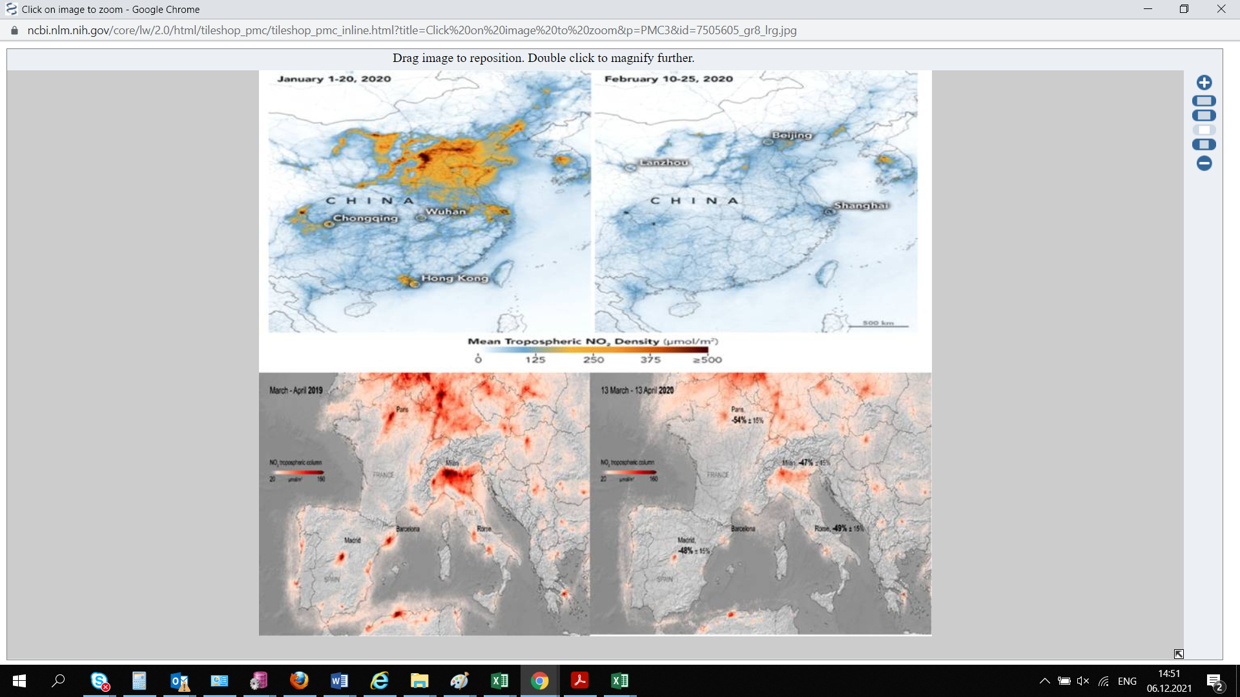

**Figure 1:** Logo of the IRETC Publisher (Times New Roman, 12)

**Conclusions** (Times New Roman, 12)

Each manuscript should contain a conclusion section within 250-450 words which may contain the major outcome of the work, highlighting its importance, limitation, relevance, application and recommendation. Conclusion should be written in continuous manner with running sentences which normally includes main outcome of the research work, its application, limitation and recommendation. Do not use any subheading, citation, references to other part of the manuscript, or point list within the conclusion.

**Declarations** (Times New Roman, 12)

The manuscript has not been submitted to any other journal or conference.

**Study Limitations** (Times New Roman, 12)

Provide all possible limitation faced in the study which might significantly affect research outcome, If not applicable write, none.

**Acknowledgements** (Times New Roman, 12)

All acknowledgments (if any) should be included in a separate section before the references and may include list of peoples who contributed to the work in the manuscript but not listed in the author list.

The author would like to express gratitude to the care support workers and elderly individuals who participated in this study, sharing their invaluable insights and experiences. Their cooperation and openness have significantly contributed to the depth and richness of the research findings.

**Funding source** (Times New Roman, 12)

Provide funding source, supporting grants with grant number. The name of funding agencies should be written in full, if no funding source exist, write, none.

**Competing Interests** (Times New Roman, 12)

Declare any potential conflict of interest exist in this publication.

**Human and Animal Related Study** (Times New Roman, 12)

If the work involves the use of human/animal subjects, each manuscript should contain the following subheadings under the declarations section-

**Ethical Approval** (Times New Roman, 12)

Provide ethical approval authority name with the reference number. If ethical approval is not required, provide an ethical exemption letter of not required. The author should send scan copy (in pdf) of the ethical approval/exemption letter obtained from IRB/ethical committee or institutional head.

**Informed Consent** (Times New Roman, 12)

Write a statement of informed consent taken from the participants to publish this research work. The editor may ask to upload scan copy if required.

**References** (Times New Roman, 12)

Author(s) are responsible for ensuring that the information in each reference is complete and accurate. **Do not use grey literature (unauthentic website, news portal, social media, Wikipedia etc) as reference, only scholarly literature (Journal, online books, proceedings, patents, authentic websites with permanent archival policy) are acceptable references.** Author should include sufficient recent (last 2 years) references in the article. All references must be numbered consecutively and citations of references in the text should be identified using numbers in square brackets (e.g., “as explained by AIJR [1]”; “as discussed in many reports [2]-[6]”). All references should be cited within the text correctly; do not add only list of references without citation within the text. All cited references should be listed after declarations section in the following style-

1. W. S. Author, “Title of paper,” Name of Journal in italic, vol. x, no. x, pp. xxx-xxx, Abbrev. Month, year. https://doi.org/10.21467/ajgr
2. Bahishti, “Peer Review; Critical Process of a Scholarly Publication”, J. Mod. Mater., vol. 2, no. 1, pp. 1.1-1.2, Oct. 2016. https://doi.org/10.21467/jmm.2.1.1.1-1.2
3. Bahishti, “A New Multidisciplinary Journal; International Annals of Science”, Int. Ann. Sci., vol. 1, no. 1, pp. 1.1-1.2, Feb. 2017. https://journals.aijr.in/index.php/ias/article/view/163
4. W. S. Author, “Title of paper,” Name of Journal in italic, vol. x, no. x, pp. xxx-xxx, Abbrev. Month, year. Access online on 20 March 2018 at https://www.aijr.in/journal-list/advanced-journal-graduate-research/
5. W. S. Author, “Title of paper,” Name of Journal in italic, vol. x, no. x, pp. xxx-xxx, Abbrev. Month, year. Access online on 5 March 2018 at https://www.aijr.in/about/publication-ethics/
6. M. Ahmad, “Importance of Modeling and Simulation of Materials in Research”, J. Mod. Sim. Mater., vol. 1, no. 1, pp. 1-2, Jan. 2018. DOI: https://doi.org/10.21467/jmsm.1.1.1-2

Main features of citation style are given as-

* The author name format is, "first name (Initial), middle name (Initial) and last name". This differs from other styles where author's last name is first.
* The title of an article (or chapter, conference paper, patent, etc.) is in quotation marks.
* The title of the book or journal is in italics.
* Online link of the original paper. If any reference is not available online, it should be modified with available online reference.

**Название статьи (14 пунктов, полужирный шрифт, Times New Roman)**

**Имя первого автора1, Имя второго автора2, Имя третьего автора3,** …….

(Times New Roman, 12)

1Принадлежность (кафедра, факультет/колледж, институт/университет)

2,3Аффилиация других авторов, если отличается (кафедра, факультет/колледж, институт/университет)

Электронная почта ответственного автора:

(Times New Roman, 10)

Тип статьи: Информацию о допустимых типах статей см. в политике раздела журнала.

**АННОТАЦИЯ** (Times New Roman, 12)

Рукопись должна содержать аннотацию в пределах 300 слов. Рукопись должна иметь самодостаточный реферат без цитирования и кратко излагать цель исследования, методологию, основные результаты и основные выводы. Аннотация должна быть в одном абзаце с предложениями. Не используйте подзаголовки или список точек в аннотации. Кроме того, следует избегать нестандартных или необычных сокращений, но, если они необходимы, они должны быть определены при их первом упоминании в самом реферате.

Ключевые слова: Авторам рекомендуется указывать 3-5 ключевых слов, относящихся к статье, через запятую. Эти ключевые слова будут использоваться для целей индексации.

**Məqalənin adı (14 punkt, Qalın, Times New Roman)**

**Birinci Müəllifin Adı1, İkinci Müəllifin Adı2, Üçüncü Müəllifin Adı3,**  (Times New Roman, 12)

1Afiliasiya (Departament, Fakültə/Kollec, Müəssisə/Universitet)

2, 3Əgər fərqlidirsə, digər müəlliflərin mənsubiyyəti (Departament, Fakültə/Kollec, Müəssisə/Universitet)

Cavabdeh müəllifin e-poçtu:

(Times New Roman, 10)

Məqalə növü: Məqbul məqalə növləri üçün jurnalın bölmə siyasətinə baxın.

**XÜLASƏ** (Times New Roman, 12)

Əlyazmada 300 sözdən ibarət abstrakt olmalıdır. Əlyazma öz məzmunlu, sitatsız bir referat olmalıdır və tədqiqatın məqsədini, metodologiyasını, əsas nəticələrini və əsas alınmış nəticələri qısa şəkildə ifadə etməlidir. Xülasə davam edən cümlələrlə bir paraqrafda olmalıdır. Xülasədə heç bir alt başlıq və ya nöqtələr siyahısından istifadə etməyin. Bundan əlavə, qeyri-standart və ya qeyri-adi abbreviaturalardan qaçmaq lazımdır, onlara ehtiyac olduqda, onlar xülasədə qeyd edilməklə yerləri təyin olunmalıdır.

**Açar sözlər:** Müəlliflərə məqaləyə aid 3-5 açar sözü vergüllə ayıraraq yazmaları tövsiyə olunur. Bu açar sözlər indeksləşdirmə məqsədilə istifadə olunacaq.

Complete Detail of Each Author

Provide complete detail of each author in the following format as well as add each author with complete detail during online submission (step 3) in the same order as appears in the manuscript.

First Author’s Full Name: (Times New Roman, 12)  
Highest Qualification:  
Department:  
Post/Rank (If a student, provide course name and course year):  
Affiliation (College/University/Institute) with postal address:  
email id:  
ORCID:

Mobile:

Second Author’s Full Name: (Times New Roman, 12)  
Highest Qualification:  
Department:  
Post/Rank (If a student, provide course name and course year):  
Affiliation (College/University/Institute) with postal address:  
email id:  
ORCID:

Mobile:

Third Author’s Full Name: (Times New Roman, 12)  
Highest Qualification:  
Department:  
Post/Rank (If a student, provide course name and course year):  
Affiliation (College/University/Institute) with postal address:  
email id:  
ORCID:

Mobile: